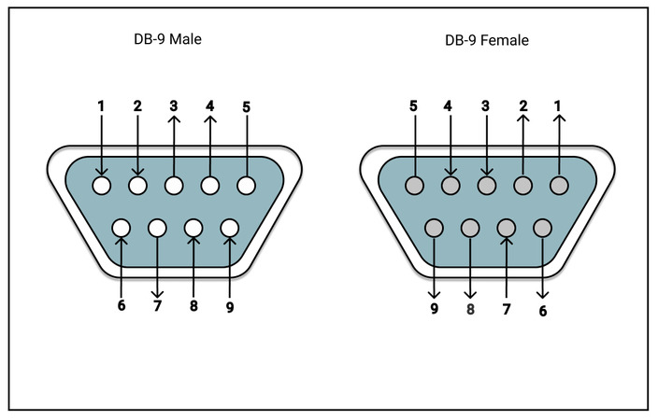

1. Empty
2. Reverse
3. 5v
4. X-as
5. Empty
6. Ground
7. 5v
8. Z-as